Just A Short Run - 5K Run/Walk, 1/2 Marathon & 30K to be held Saturday March 26, 2005 is the 5th of 6 races in the Elite Runners & Walkers Golden Triangle Race Series. All 3 races at this event will begin simultaneously at 8:30 am.
JASR is also a great warm-up run for any late spring Marathon. Its proceeds will benefit the Western Area Chapter of the Leukemia & Lymphoma Society.
Please check out our site for information pertaining to the race as well as information on the Golden Triangle Race Series.
Online Registration
Registration fees are as follows
1/2 Marathon $25 on or before March 12th $30 after March 12th
5K Run/Walk $18 on or before March 12th $20 after March 12th
30K individual $30 on or before March 12th $35 after March 12th
Click on the HUGE LOGO on the home page or go to the Register online page FOR DIRECT LINK TO ONLINE REGISTRATION!
We encourage all participants to use this service as it ensures accuracy of your info as you are typing it, plus it gives us an easy to use database for our race packets.
Standard snail mail will still be accepted. Simply, print off the entry form located on the Print Applications page and send with a check payable to:
Just A Short Run - LLS
c/o Elite Runners & Walkers
5992-E Steubenville Pike
Grand Prize Awards are set!
For the 5th year in a row, thanks to the generosity of Denise Gantose of Ohio, we will raffle off a week at an Ocean City, MD condo which holds 8 people. Located on the oceanside only 30 feet from the beach this is a terrific prize. Winners must be present at final call to receive prize.
Also up for grabs will be a custom framed poster of Pre, valued at $250, assorted running clothes & shoes donated by New Balance, Mizuno, Asics, Brooks, & more As with the condo the winners of these prizes must be present when their number is called.
Many other raffle prizes will be up for grabs and will be drawn during the races and posted for your convenience.
All registered participants are eligible for drawings. All numbers of those left at the end will be put back into the pot for the grand prizes listed above.
Good Luck on Race Day.
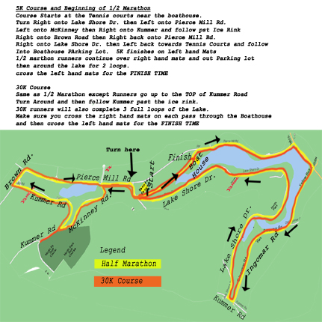
Click on map to get driving directions from yahoo maps

Course Map
This is the official Course Map revised in 2002. We changed the 5K course in 2002 so it now mimics the first part of the 1/2 marathon/30K course going around the ice rink. In addition, it shows in red the additional areas that must be covered by the 30K runners.
It was recertified in 2003 as all the courses were found to be .1 mile too long.
The course is gently rolling with the exception of one challenging hill situated between mile 1 and two. For the 30K runners it is a slightly more challenging as they must go to the top. The rest of the runners only go up 1/2.

Tired of Dieting?

Peak Performance and Weight Loss Lecture

Where: Northland Public Library

When: Saturday, January 15th 11:00 a.m.

Dr. Ray Vactor will discuss a unique 5 step program that will quickly increase energy, productivity and weight loss.

Bring a Friend!

To register, call 724-935-1610 or 724-316-6199

